**RESUME**

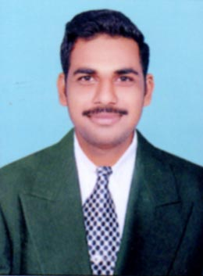

**Undrakonda Gopi**

Mail Id:undrakonda.gopi@gmail.com

Mob #: +91 –9676529554

**OBJECTIVE**

I would like to associate myself with a progressive and professional organization, where there is growth and potential realization of person’s abilities and skills.

**PERSONAL SKILLS**

###### Comprehensive problem solving capabilities, excellent verbal and written communication skills, Ability to deal with people diplomatically, willingness to learn, Team facilitator.

**ACADEMIC PROFICIENCY**

* **M.Tech In PE & D** with an aggregate of **70%** fromKKR & KSR Institute Of Technology & Sciences,Guntur of JNTU Kakinadaduring the period **2013-2015.**
* **B.Tech in EEE** with an aggregate of **64.03%** from ST.Mary’s Engineering College, Guntur of JNTU Kakinadaduring the period **2008-2012.**
* **Intermediate** with an aggregate of **72.7%** from Sujatha JR.College,Ponnur BOARD of intermediate during the period **2006-2008.**
* **SSC** with an aggregate of **76.3%** from **L.C.E.M** School,Ponnur of Secondary Education during the period **2005-2006.**

**TECHNICAL SKILLS**

* **Other Software’s Exp** : MATLAB, P-SPICE.
* **Programming languages** : DEVOPS,DOTNET,ORACLE,MS-OFFICE.

**Project Experience**

**Project Title :**  “SIMULATION OF THREE PHASE HYBRID MULTILEVEL INVERTER USING SWITCHED CAPACITOR UNITS FED INDUCTION MOTOR DRIVE ”

**Duration : 1 Year.**

**Database : MATLAB.**

**Description :** This project Highlights A Hybrid Multilevel inverter For AC Electrical Drives. In Recent days Multilevel inverters has become very popular For Motor Drive Applications Of Industry.

**EXTRA CURRICULAR ACTIVITIES**

* Participated in college and school level debate and essay competition and received applauds.
* Participated as Event organizer in all school and college annual day functions and other technical events.
* Participated in ROBOTICS camp held at IIIT Hyderabad.

**STRENGTHS**

* My strength is self confident, learning ability, hardworking, team work. I can easily adopt any kind of environment these will help to form comfortable in my work.

**PERSONAL DETAILS**

**Name :** U.Gopi

**Date of Birth :** JUNE 18, 1991

**Father’s Name :** SRINIVASA RAO

**Marital Status :** Single

**Languages Known :** English, Telugu,Hindi

**Hobbies :** Playing cricket and Listening to Music

**Address :** Undrakonda Srinivasa Rao,

D.No: 1-16,

Sitaramapuram (Village),

Upparapalem (post), Ponnur (Mandal),

Guntur (District),

Pin No: 522124.

**DECLARATION**

I do hereby declare that the information stated above is true and correct to the best of my knowledge and belief.

**PLACE:**

**DATE: (Undrakonda Gopi)**